**SOFTWARE ENGINEERING ASSIGNMENT**

MODULE:01

SE-OVERVIEW OF IT INDUSTRY

**Que-1 What is software? What is software engineering?**

**Ans: -**Software is a set of instruction, data or programs used to operate computers execute specific tasks.

* **Software engineering:** -

1. Software engineering is a technique through which we can developed or created software for computer systems and any other electronic device.
2. In other words, software engineering is a process in which user needs are analyzed and software is a designed based on their needs.
3. In software engineering the development. f software using well define scientific principal method and procedures.
4. Software engineers build these software and applications by using designing and programming languages.

**Que-2 Explain types of software.**

**Ans: -**There are 5 types of software.

* Application software
* System software
* Driver software
* Middleware
* Programming software

1. **Application software: -**Application software is type of computer program that perform a specific personal, educational, and business function. Each application is designed to assist end-users in accomplishing a variety of tasks, which may be related to productivity, creativity or communication.
2. **System software: -**system software is a types of computer program that is designed to run a computer’s hardware and application programs. If we think of the computer system as a layered model, the system software is the between the hardware and user applications.
3. **Driver software: -**Is a driver software is a types of software program that controls a hardware device. On any computer, smartphone, tablet, different hardware components that are part of the computer and attached devices need to communicate with each other for a computer to function and work as well.
4. **Middleware: -**Middleware is software and cloud services that provide common services and capabilities to applications and help developers and operators build and deploy applications more efficiently. middleware acts like the connective tissue between applications, data, and users.
5. **Programming software: -**programming software is a tool for creating computer code that allows the computer software to operate. The computer technology field frequently uses overlapping terminology. Development is the actual design of the program, whereas programming is the execution of development instructions.

**Que-3** what is SDLC? explain each phase of SDLC?

**Ans:-**Software development life cycle .

* There is total 6 phases in SDLC methodology.

1. Requirement gathering
2. Analysis
3. Designing
4. Implementation
5. Testing
6. Maintenance

* **Requirement gathering-**An essential first step in acquiring an information system is requirements gathering. Requirement gathering is an exploratory process that involves researching and documenting a project’s requirement from start to finish.
* **Analysis-** Feasibility analysis is the process by which feasibility is measured. The feasibility analysis in a project that a feasible at one point in time may become infeasible at a later point in time.
* **Designing-** In SDLC, the design phase is a stage where software development defines the technical details of the product.
* **Implementation-** This phase is initiated after the system has been tested and accepted by the user.
* **Testing-**Once the developers build the software, then it deployed in the testing environment. Then the testing team tests the functionality of the entire system.
* **Maintenance-**The maintenance phase happens after the project team deploys the software and it’s fully operational in the customer environment.

**Que-4 What is DFD? Create a DFD diagram on flipkart**

**Ans:-** A data flow diagram is a way of representing a flow of data through a process or a system. The DFD is also provides information about the outputs and inputs of each entity and the process itself.

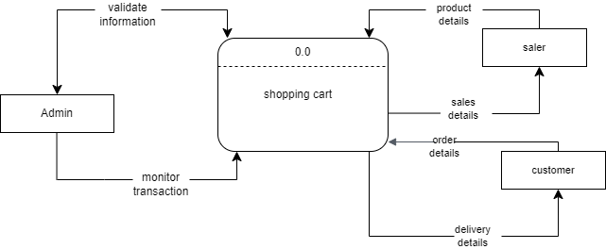

**Que-5 What is flowchart? Create a flowchart to make addition of two numbers.**

**Ans: -** A flowchart is a diagram that depicts a process, system or computer algorithm. They are widely used in multiple fields to document, study, plan, improve and communication often complex processes in clear, easy-to-understand diagrams.

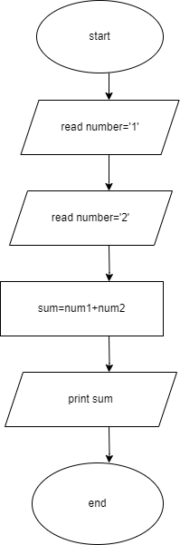

**Que-6 what is use case diagram? Create a use-case on bill payment on Paytm.**

**Ans: -**Use-case diagrams describe the high-level functions and scope of a system. These diagrams identify the interactions between the system and its actors.

